Poster Sessions

The conference will have two poster sessions:

Session 1 (odd # posters) : Friday, 10 Nov, 15:55–16:30
Session 2 (even # posters) : Saturday, 11 Nov, 11:00–11:30

Poster numbers will be assigned after acceptance and presenters of posters will be notified via e-mail.

Poster presentations play a key role in GeoMundus’ purpose of raising awareness about current pressing issues and addressing topical challenges associated with geospatial technologies, as well as networking to facilitate cooperation and collaboration. Time will be dedicated to viewing posters during the meeting’s breaks, during the Welcome Reception, and during the Poster Sessions, allowing attendees many opportunities to interact and share details of their work.

Poster Specifications

Posters will be limited to 112 cm high x 84 cm wide (A0 size).

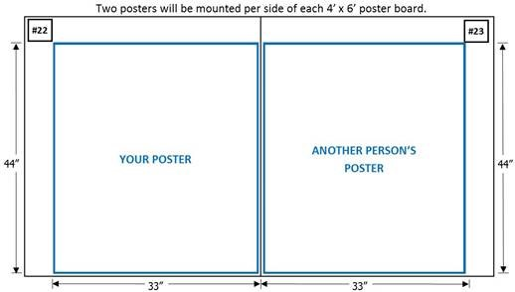

- Due to limited space, two poster presentations will be mounted to each side of the poster boards.
- Please follow size limits so there is space for a poster number in the upper corner of the board.
- Each poster will be assigned a number in advance so that poster presenters will know where to place their poster.
- Poster presenters must use the poster boards provided by the Conference.
- Poster boards are covered with fabric, and posters can be affixed using either Velcro or push pins. Tape is not permitted. A limited supply of Velcro tape will be available for use during mounting, so bring extra if needed.
- Morning and afternoon refreshments will be served in the poster room each day, in addition to the Welcome Reception and two Poster Sessions, allowing plenty of time for visibility and networking.

